Practical No. 3
Aim : Design Mobile phone screen using design tools
Name : Danish Altaf Solkar | Class : CO - B
Enrolment no. : 24111590805 | Batch : 2

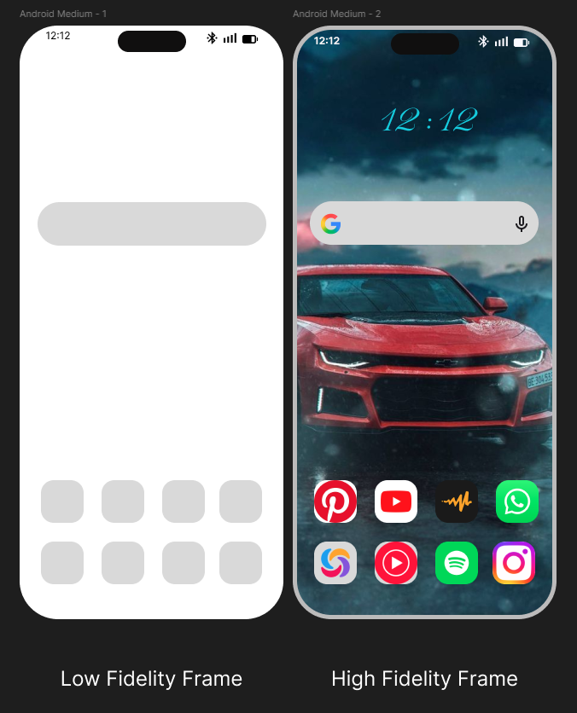

Process related  (15) | Product related  (10) | Total Marks  (25) | Signature

